12 The Life of a Packet - Lab Exercise

This lab explores DNS configuration on Cisco routers and the ARP cache.

Lab Topology

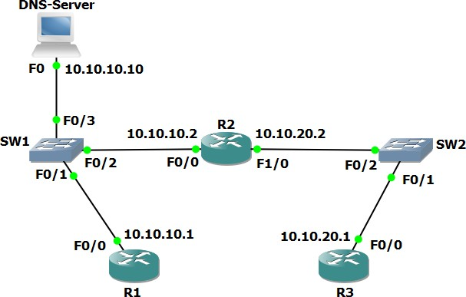

Load the Startup Configurations

Open the ’12 The Life of a Packet.pkt’ file in Packet Tracer to load the lab.

This configures the lab topology as shown above and adds static routes between R1 and R3.

Configure the Routers as DNS Clients

Note that routers cannot be DNS servers in Packet Tracer (it does not support the ‘ip dns server’ command) so we are using a Packet Tracer server device as the DNS server.

The host with IP address 10.10.10.10 has been configured as a DNS server and is able to resolve DNS requests for ‘R1’, ‘R2’ and ‘R3’.
A domain name is not in use.

- Configure R1, R2 and R3 to use 10.10.10.10 as their DNS server. You do not need to configure a domain-name or domain-list.

- Verify that you can ping R2 and R3 from R1 using their hostnames ‘R2’ and ‘R3’ (it may take some time for the DNS server to resolve the DNS request).

- Verify that you can ping R1 and R2 from R3 using their hostnames ‘R1’ and ‘R2’.

Examine the ARP Cache on the Routers

- Do you expect to see an entry for R3 in the ARP cache of R1? Why or why not?

- Verify the ARP cache on R1, R2 and R3. What do you see?

